Web tasks 3

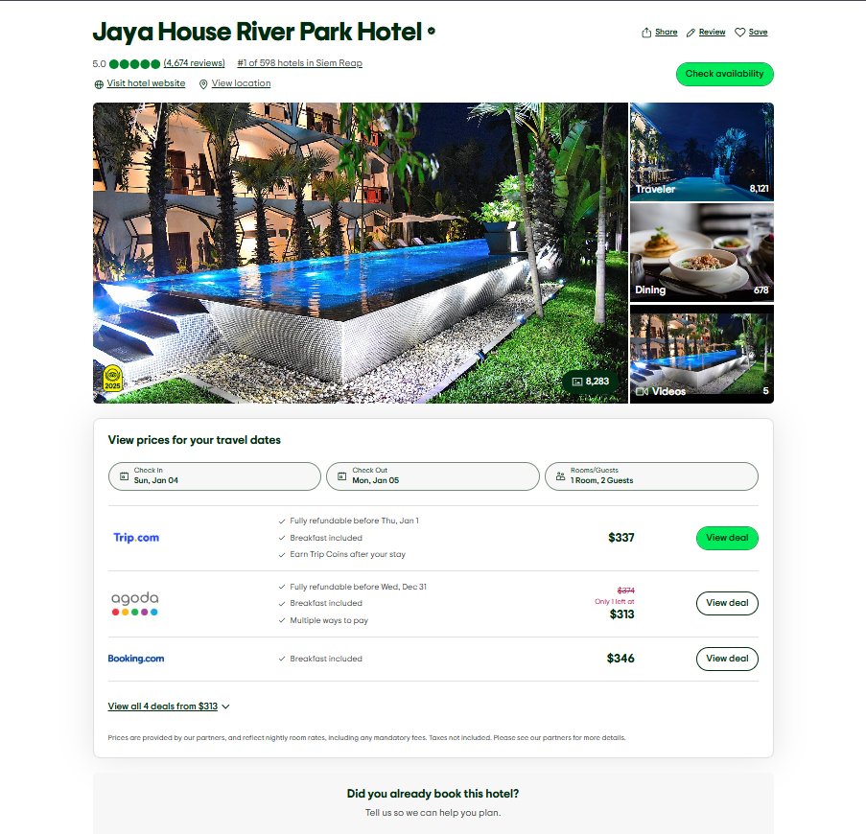
Ahmed nour :

Rodina & mohaned: (Rodina left section mohaned right section ) noteeeeeee (two sections in one page don’t make two pages )


Ahmed hossam : 